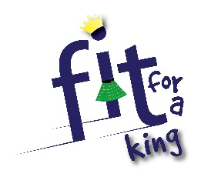
Holiday Club Registration &
Consent Form Aug 4th- 8th 2014
Child’ full name:  Please use a separate form for each child | Date of birth:  Class in August: | Sex please circle  Male  Female
Address & Post Code: | Emergency contact name:  Phone number:
Home phone number: | Email address:
GP’s name: | GP’s phone number:
Any known allergies, medicines or conditions [Please include details]:

If your child uses an inhaler or other medication, please ensure they have it with them every day.
I give permission for my child’s and my details to be entered on the church database. YES / NO
Photography/Video Consent

West Kirk of Calder and Polbeth Harwood Parish Church of Scotland are committed to ensuring good practice is followed in relation to the use of photography/video within church activities. This includes adherence to safe storage guidelines as outlined in the Good Practice Guidelines for use of photography/video at children’s events within the Church of Scotland.

I give permission for my child’s photograph to be taken during the club. YES / NO
[The photographs will be used for church purposes only, including church magazines and church website]
I confirm that the above details are complete and correct to the best of my knowledge.

In the unlikely event of illness or accident I give permission for any appropriate first aid to be given by the nominated first aider. In the event of an emergency, and if I cannot be contacted, I am willing for my child to receive hospital treatment, including anaesthetic if necessary. I understand that every effort will be made to contact me as soon as possible.

Signature of Parent / Guardian______________________________________________________________

PRINT NAME_____________________________________________ Date:_______________________

All children must be brought to and collected from Polbeth Harwood Parish Church by an adult
[over 16 years of age] Drop off 10am and collected at 12.30pm
Polbeth Harwood Parish Church: Scottish Charity SC17373 | West Kirk of Calder Church of Scotland: Scottish Charity SCO04703

